EX.No. : 6

SELECT with various clause – BETWEEN, IN, Aggregate function

AIM:
To view the records from the Saveetha Hospital table using SELECT commands with BETWEEN, IN and Aggregate Functions.

DESCRIPTION:
The BETWEEN operator tests whether a value lies within a specified range. The IN operator checks whether a value matches any value in a specified list. Aggregate functions such as AVG, COUNT, SUM, MIN and MAX perform calculations on a set of rows.

BETWEEN Operator:
SELECT column1, column2, ... FROM table_name WHERE expression [NOT] BETWEEN begin_value AND end_value;

IN Operator:
SELECT column1, column2, ... FROM table_name WHERE column_name IN ('value1','value2',...);

Aggregate Functions:
AVG() – average value
MAX() – maximum value
MIN() – minimum value
SUM() – total value
COUNT() – number of rows

Saveetha Hospital Dataset:
patients(patient_name, ward, treatment, doctor, operation, operation_fee)

Questions:
IN & BETWEEN
1. List the treatment types 'Heart Attack' and 'Accident'.
2. List the patients whose operation fees are in the range 5000 to 50000.
AGGREGATE
1. Find the average operation fee of patients who underwent an operation.
2. List the maximum and minimum operation fee for patients who underwent an operation.
3. List the maximum, minimum and average operation fee for each operation status.
4. List the treatment and average operation fee of each treatment.
5. Calculate the sum of all the operation fees.
6. How many patients are recorded for each treatment? Display the treatment and number of patients.
7. How many treatments did each patient register for?

OUTPUTS: IN & BETWEEN

1. List the treatment types 'Heart Attack' and 'Accident'.
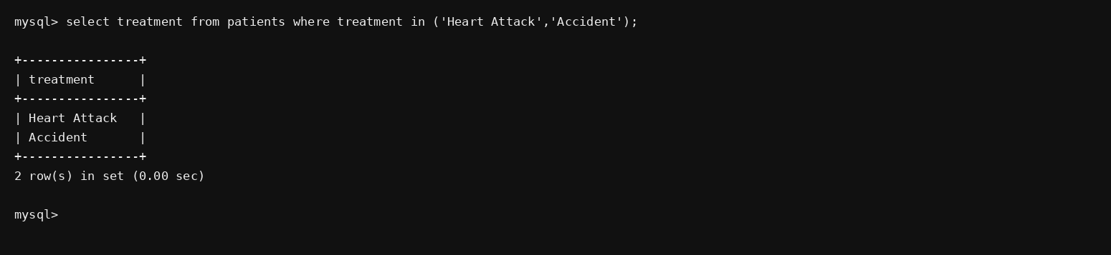

2. List the patients whose operation fees are in the range 5000 to 50000.
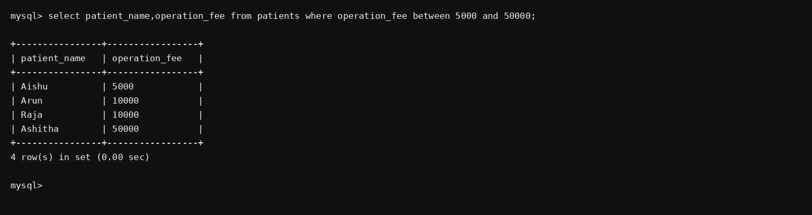

OUTPUTS: AGGREGATE

AGGREGATE
1. Find the average operation fee of patients who underwent an operation.
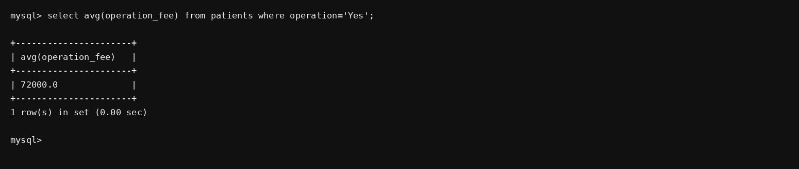

2. List the maximum and minimum operation fee for patients who underwent an operation.
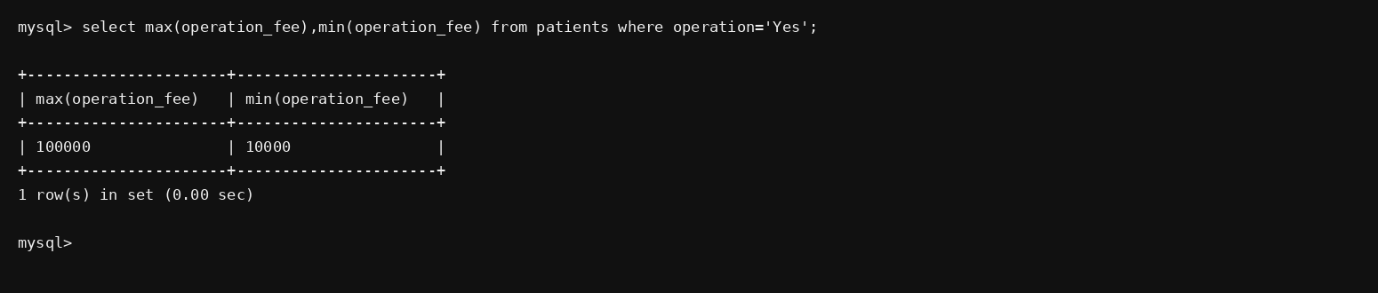

3. List the maximum, minimum and average operation fee for each operation status.
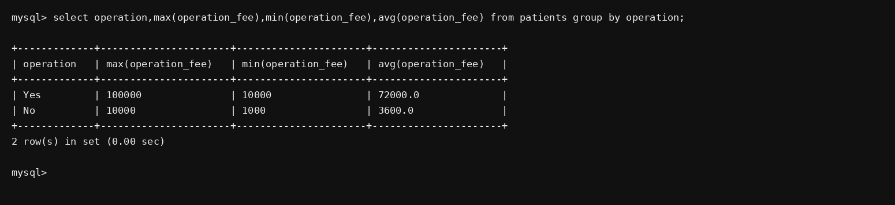

4. List the treatment and average operation fee of each treatment.
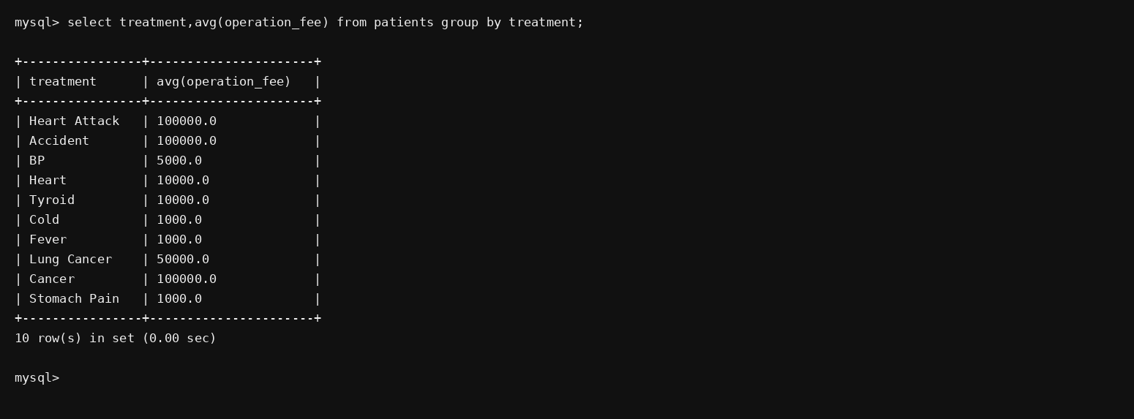

5. Calculate the sum of all the operation fees.
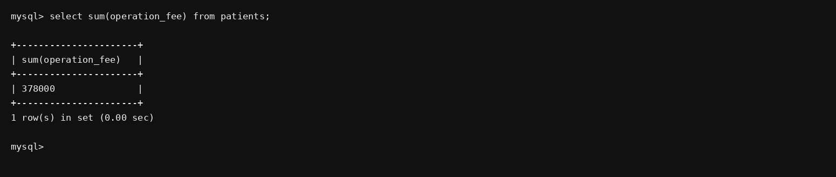

6. How many patients are recorded for each treatment? Display the treatment and number of patients.
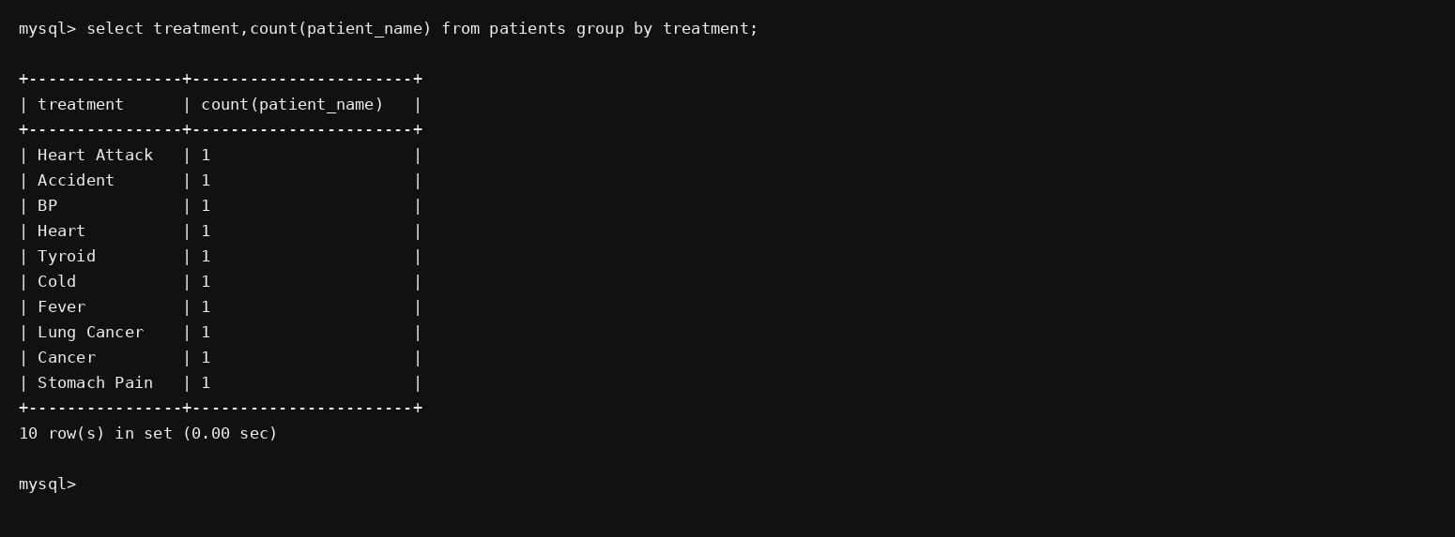

7. How many treatments did each patient register for?
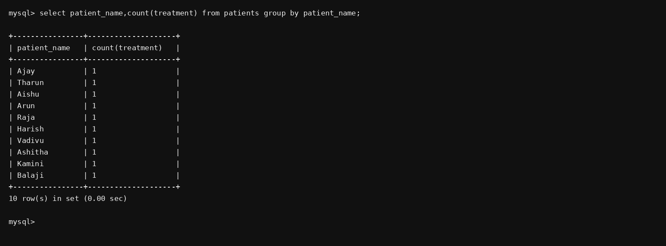

RESULT:
The records from the Saveetha Hospital table are successfully retrieved using SELECT commands with BETWEEN, IN and aggregate functions.

